Operation Windsor
15
MILITARY

2ND BRIT 1ST CAN
AIR POWER
JABOS: +1 2nd BRIT; +1st CAN
RESOURCES
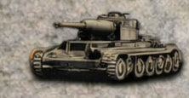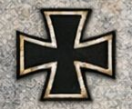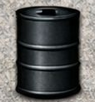
10th SS Pz Lose 1 Lose 2

ORDERS: 4 Actions
+1 Attack Strength BRIT 1st ARMY
+1 Attack Strength CAN 1st ARMY

Operation Windsor was a Canadian offensive launched between 4–5 July 1944, the attack was undertaken by the 3rd Canadian Infantry Division in an attempt to capture the Norman town of Carpiquet and the adjacent airfield from German forces. The attack was originally intended to take place during the later stages of Operation Epsom, as a means of protecting the eastern flank of the main assault. It was postponed and launched the following week.

